PayFlow API Assignment Write-Up

Student Name
Akshaya V

Task 1 – Project Setup

Technologies Used
- Spring Boot 3.x
- Spring Web
- Spring Data JPA
- H2 Database

Package Structure
The project is organized into four layers:

entity
Contains the JPA entity classes (User and Transaction) that map Java objects to database tables.

repository
Contains repository interfaces that extend JpaRepository. These provide CRUD operations and custom query methods.

service
Contains business logic. Controllers delegate work to services instead of directly accessing repositories.

controller
Contains REST API endpoints that receive HTTP requests and return HTTP responses.

How to Run the Application
- Open the project in IntelliJ IDEA.
- Allow Maven dependencies to download.
- Run PayflowApiApplication.
- Open the browser and navigate to:
http://localhost:8080/h2-console
- Connect using:
JDBC URL: jdbc:h2:mem:payflowdb
Username: sa
Password: (blank)

Spring Boot Features Used

Embedded Server
Spring Boot includes an embedded Tomcat server. The application runs directly by executing the main class without deploying a WAR file to an external server.

Auto-Configuration
Spring Boot automatically configures H2 Database, Spring MVC, Jackson JSON processing, Hibernate, and JPA repositories based on dependencies present in the project.

Production-Ready Defaults
Spring Boot provides sensible defaults such as logging configuration, error handling, dependency management, and application startup configuration.

Task 2 – Entities and Database

User Entity
Fields:
- id
- name
- upiId
- phoneNumber
- balance
Annotations:
- @Entity
- @Id
- @GeneratedValue

Transaction Entity
Fields:
- id
- senderUpiId
- receiverUpiId
- amount
- createdAt
Annotations:
- @Entity
- @Id
- @GeneratedValue

Hibernate Generated SQL

Users Table
create table users (
balance numeric(38,2),
id bigint generated by default as identity,
name varchar(255),
phone_number varchar(255),
upi_id varchar(255),
primary key (id)
)

Transactions Table
create table transactions (
amount numeric(38,2),
created_at timestamp(6),
id bigint generated by default as identity,
receiver_upi_id varchar(255),
sender_upi_id varchar(255),
primary key (id)
)

H2 Console Screenshots

Empty USERS Table

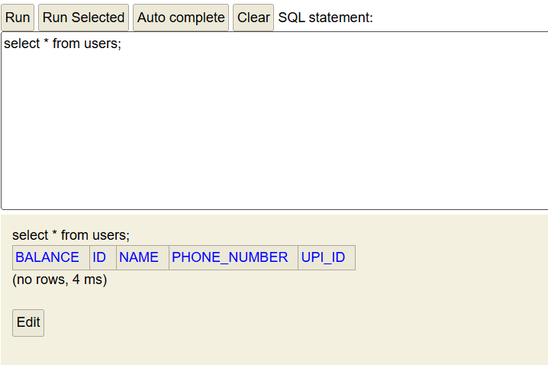

Empty TRANSACTIONS Table
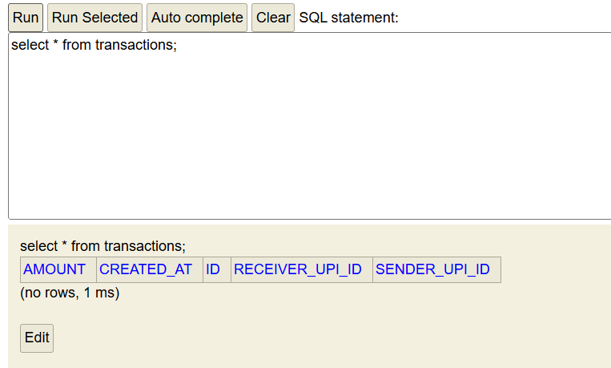

Task 3 – Repository Layer

UserRepository
Optional<User> findByUpiId(String upiId);

TransactionRepository
public interface TransactionRepository extends JpaRepository<Transaction, Long>

SQL Generated for findByUpiId
Example:
select
u1_0.id,
u1_0.balance,
u1_0.name,
u1_0.phone_number,
u1_0.upi_id
from users u1_0
where u1_0.upi_id=?

Explanation
Spring Data JPA derives the query automatically from the method name findByUpiId.
The word findBy tells Spring that a SELECT query is required.
The property name UpiId matches the field upiId in the entity.
The ? symbol is a parameter placeholder. At runtime Spring replaces it with the value passed into the method.

Task 4 – Service Layer

UserService Methods
- registerUser()
- getAllUsers()
- getUserById()
- findByUpiId()

TransactionService Methods
- sendMoney()
Currently sendMoney() only stores the transaction record. It does not update balances because the assignment specifically states that balance deduction logic is not required.

Task 5 – Controller and REST Endpoints

POST /users

Curl Command
curl -X POST http://localhost:8080/users ^
-H "Content-Type: application/json" ^
-d "{\"name\":\"Priya\",\"upiId\":\"priya@okaxis\",\"phoneNumber\":\"9999999999\",\"balance\":5000}"
curl -X POST http://localhost:8080/users ^
-H "Content-Type: application/json" ^
-d "{\"name\":\"Rahul\",\"upiId\":\"rahul@upi\",\"phoneNumber\":\"8888888888\",\"balance\":3000}"

Output
{"id":1,"name":"Priya","upiId":"priya@okaxis","phoneNumber":"9999999999","balance":5000}
{"id":2,"name":"Rahul","upiId":"rahul@upi","phoneNumber":"8888888888","balance":3000}

GET /users

Curl Command

curl http://localhost:8080/users

[{"id":1,"name":"Priya","upiId":"priya@okaxis","phoneNumber":"9999999999","balance":5000.00},{"id":2,"name":"Rahul","upiId":"rahul@upi","phoneNumber":"8888888888","balance":3000.00}]

GET /users/{id}

Curl Command
curl http://localhost:8080/users/1
{"id":1,"name":"Priya","upiId":"priya@okaxis","phoneNumber":"9999999999","balance":5000.00}

POST /transactions

Curl Command
curl -X POST http://localhost:8080/transactions ^
More? -H "Content-Type: application/json" ^
More? -d "{\"senderUpiId\":\"priya@okaxis\",\"receiverUpiId\":\"rahul@upi\",\"amount\":500}"
{"id":1,"senderUpiId":"priya@okaxis","receiverUpiId":"rahul@upi","amount":500,"createdAt":"2026-06-13T20:11:05.3772675"}

Database After Testing

USERS Table,TRANSACTIONS Table

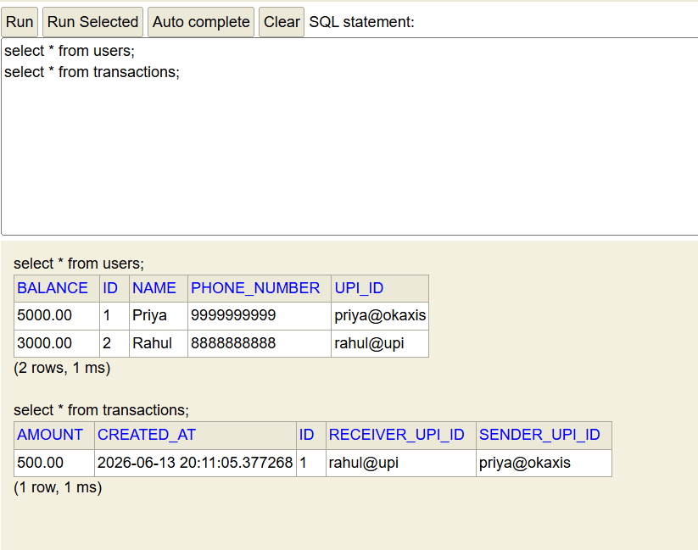

Demonstration of @RequestBody

With @RequestBody
Controller receives:
User{name='Priya', upiId='priya@okaxis', ...}

Without @RequestBody
Controller receives:
User{name=null, upiId=null, ...}

Explanation
@RequestBody instructs Spring MVC to read the JSON payload from the HTTP request body and convert it into a Java object using Jackson. Without @RequestBody, Spring does not parse the JSON request body. As a result, the fields of the User object remain null because no values are bound to the object.

Task 6 – Custom Query

Derived Query Method
findByUpiId(String upiId)
Spring automatically generates SQL based on the method name.

Curl Command
GET /users/upi/{upiId}
curl http://localhost:8080/users/upi/priya@okaxis
{"id":1,"name":"Priya","upiId":"priya@okaxis","phoneNumber":"9999999999","balance":5000.00}

JPQL Query
@Query("SELECT u FROM User u WHERE u.balance > :minBalance")
List<User> findUsersWithBalanceGreaterThan(Double minBalance);

Comparison of Query Approaches

Derived Query Methods
Generated automatically by Spring Data JPA based on method names. Easy to write and maintain.

JPQL Queries
Written using entity names and fields instead of database table names. More flexible than derived query methods.

Native SQL Queries
Written directly against database tables. They are database-specific, harder to maintain, and reduce portability. Therefore native queries are generally the least preferred approach.

Conceptual Questions

1. Request Lifecycle
When a client sends a POST request to /users, the request first reaches the embedded Tomcat server. Tomcat forwards the request to Spring MVC's DispatcherServlet, which acts as the front controller. The DispatcherServlet consults a HandlerMapping to find the correct controller method and then uses a HandlerAdapter to invoke that method. After the controller method executes, Spring converts the returned object into JSON and sends it back to the client.

2. Serialization
Jackson is responsible for converting JSON into Java objects. When a JSON payload such as {"name":"Priya","upiId":"priya@okaxis"} is received, Jackson maps the JSON keys to matching Java fields. If the JSON contains upi_id instead of upiId, Jackson will not automatically find a matching field and the value may remain null unless additional configuration or annotations are used.

3. Spring Boot Features
The first Spring Boot feature is the embedded server. In this project, Tomcat runs inside the application and starts automatically. The second feature is auto-configuration, which automatically configures H2, Hibernate, Spring MVC, and JPA repositories. The third feature is production-ready defaults, which provide logging, error handling, and dependency management without manual setup.

4. Spring vs Spring Boot
If plain Spring Framework had been used, configuration for Tomcat, DispatcherServlet, database connections, Hibernate, and component scanning would have been performed manually. Spring Boot automates these configurations using auto-configuration and starter dependencies. This significantly reduces boilerplate code and setup effort.

5. Stateless REST
A stateless service does not store information about previous requests. Each request contains all information necessary for processing. This is important when multiple servers are placed behind a load balancer because any server can process any request without needing access to previous session data. Statelessness improves scalability and reliability.

6. Persistence
If transactions were stored in a Java List, all transaction data would be lost whenever the application restarted because the data would only exist in memory. By storing transactions in the H2 database, records persist for the lifetime of the database session. Persisting data is critical for payment applications because transaction history must not be lost after a restart.

